I need your access to this site for bulk personal data screening, I need homes valued at $300,000 or more and I will give you the bulk number where you will need to provide me with information including: name, age, phone number, home value, address and email.

https://www.truepeoplesearch.com/

Two things to keep in mind:

1. if it looks like a lot of people have used the number, make sure the most recent person to use the number is the correct person.

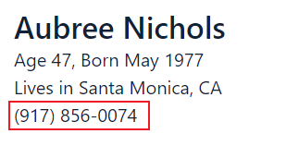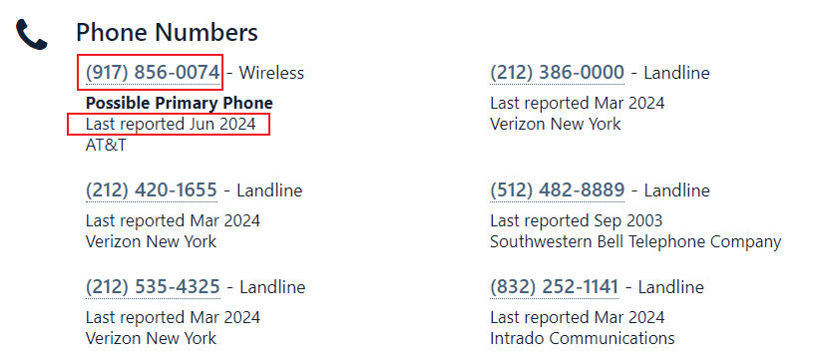

The number in the case above is correct

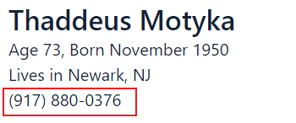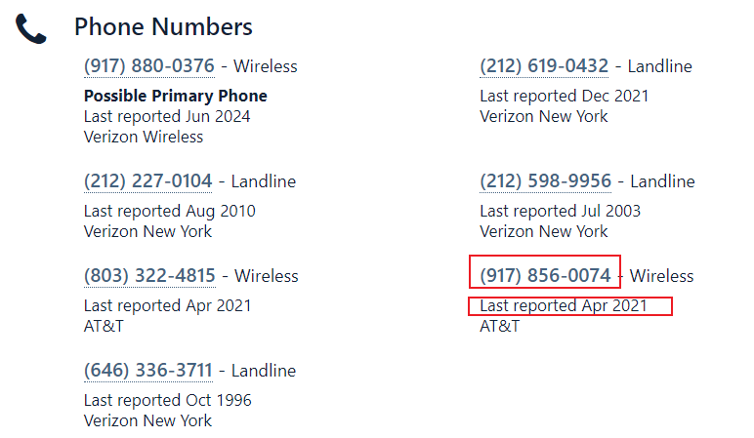

It's still the same number, this info was also searched but it's wrong, he just used the number a long time ago

Correct number has nothing to do with ranking!!!

1. in the home information, the home ownership must be of a personal nature, if it is of any other nature, it is not my client.

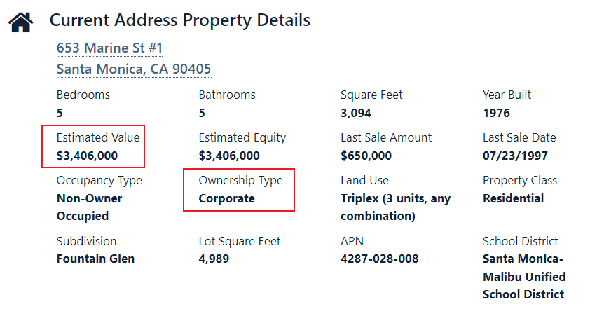

The house is worth well over $30, but it belongs to a company, so it's not what I need.

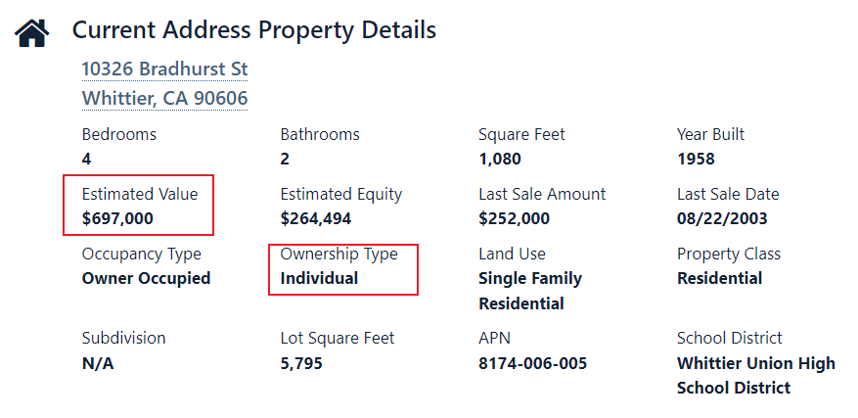

This home is worth over $300,000 dollars. Also it is personal in nature so it is the information I am looking for.

If you have confidence and need to test, please contact me, I will give you 100 numbers to test, if you need more test is also available, after the test is done, please give me a quotation, calculate the price according to the number of numbers I give you, also please tell me how many numbers you can finish screening in a day.

I will have millions or even tens of millions of numbers to be screened, I hope I can find the right partner, and I also hope you can give me a reasonable price, we can work together for a long time.

Have a nice life!